



**By: Kareem Elkhamisy**

**210520**

**Supervised By:**

**Dr. Nermin Othman**

***June 2024***

**Smart City Security System**

**Faculty of Informatics and Computer Science**

***Software Engineering***

Abstract

The term ‘smart cities’ generally refers to the use of technology-based solutions to enhance the quality of life for citizens, Smart cities are being developed worldwide with the use of technology to improve the quality of life for citizens and enhance their safety. Smart cities are designed around an Information and Communication Technology (ICT) based infrastructure with Internet of Things (IoT) enabled sensor technology to support social and urban interconnectivity through greater citizen interaction by using the role based access control model (RBAC). The problem now days is the lack of security and creativity of the security systems in the smart city which have been faced a lot of attacks lately all over the world. The aim of this project is to present an outline of security for smart cities and provide a deeper understanding of what meant by securing smart cities and discuss the applicability of existing security methods of authentication, role based access control and their appropriateness to defending a smart city and highlighting the importance of smart security systems in smart cities and to provide insights into how they could be used to enhance safety, security, and the overall quality of life for citizens. The related work proposed solutions to this problem by using role based access controls (RBAC) and internet of things (IOT) which provided high results in developing the security systems.

Turnitin Report



Table of Contents

Abstract 1

Turnitin Report 2

List of Figures 4

List of Tables 5

1 Introduction 6

1.1 Overview 6

1.2 Problem Statement 7

1.3 Scope and Objectives 7

1.4 Report Organization 8

1.5 Work Methodology 8

1.6 Work Plan (Gantt Chart) 10

2 Related Work 11

2.1 Background 11

2.2 Literature Survey 12

2.3 Analysis of the Related Work 14

3 Proposed solution 15

3.1 Solution Methodology 15

3.2 Functional/ Non-functional Requirements 17

3.3 Design / Simulation set up 17

4. Impementation 20

5. Testing and evaluation 34

5.1 Testing 34

5.2 Evaluation 36

6. Results and Discussions 36

7. Conclusions and Future Work 38

7.1 Summary 38

7.2 Future Work 38

References 39

List of Figures

Figure 1:Gnatt chart 10

Figure 2.my model 15

Figure 3.seq diagram 18

Figure 4.ERD 19

Figure 5.servo motor 21

Figure 6.RF reader 21

Figure 7 22

Figure 8 22

Figure 9 23

Figure 10 23

Figure 11 24

Figure 12 24

Figure 13 24

Figure 14 25

Figure 15 25

Figure 16 26

Figure 17 26

Figure 18 26

Figure 19 27

Figure 20 27

Figure 21 28

Figure 22 28

Figure 23 29

Figure 24 30

Figure 25 30

Figure 26 30

Figure 27 31

Figure 28 31

Figure 29 32

Figure 30 32

Figure 31 33

Figure 32 33

Figure 33 33

List of Tables

Table 1.Analysis table 14

Table 2 34

Table 3 34

Table 4 34

Table 5 35

Table 6 35

Table 7 35

# Introduction

## Overview

The “smart city” concept refers to applying all available technology and resources in an intelligent and coordinated manner with the aim of developing urban centers that are at once integrated, habitable, and sustainable, Smart cities are being developed worldwide with the use of technology to improve the quality of life of citizens and enhance their safety.

Smart cities are designed with Internet of Things (IoT) enabled sensor technology to support social and urban interconnectivity through greater citizen interaction. The aim of this project is to present an outline of security for smart cities and provide a deeper understanding of what meant by securing smart cities and discuss the applicability of existing security methods of authentication, role based access control, defense in depth concept and their appropriateness to defending a smart city, highlight the importance of smart security systems in smart cities and to provide insights into how they could be used to enhance safety, security, and the overall quality of life for citizens.

The security system for the smart city depends on two main branches “access control” and “way of authentication” Access control: our security system is based on a role-based access control model, which means that people can only access information and resources if they are authorized to do so by their organization." This method helps keep information from getting into the wrong hands and makes sure that workers can only see the information they need to do their jobs. it has two main point in our security system “authentication” and “authorization” – that refers to the policy of the city that security system follows–Way of authentication : in our security system we have three ways RF(Radio frequency) -that will be used for the owners and the staff of the city by using sensors to read the electronic chips and decide if the chip carrier is allowed to enter in that time or not- ,QR code-that will be used for the visitors by using sensors to detect and checks the code if it has bien used before or not and that the visitor is entering to which owner and Face id -that will be used for the owners of homes to make the homes safer for the people living in there.

In my project I am trying to improve privacy and security of smart cities and services and choose suitable algorithms and protocols to improve security and privacy and to repel and protect the possible attacks from connectivity (internet) and physical attacks from thieves and scammers those who enters cities to rope homes and people.

## Problem Statement

Smart cities security systems still faces several challenges that include system accuracy, scalability, real-time processing, variability, privacy, data storage, and retrieval ,so that is first problem that faces smart cities security system [2] and another problem is the software that brings some issues, The role of software within smart cities is essential, but it brings some privacy and security issues such as exchange of application data, problems related to tracking, effects of hacking, authentication of datasets, increase in personal data thefts, access to information in data centers, effect of other applications and economic pressure [5].

Another type of problems which is Problems in decision-making and the functionality of the processes and lacking of transparency in the system[6]and the most common problem in the smart cities security systems is the Security threats and issues in different layers of the IoT-based and cloud-based smart city architectures , Smart cities consist of complex, networked assemblages of digital technologies, ICT infrastructure, and IoT devices for handling different services and system throughout the cities and optimizing the resource consumption.

Since the IoT devices of smart cities require to be interconnected through different types of networks, they expose to the huge number of security risks and there are more potential entry points for attackers across networks [9]. Another type is connected Devices and Smart Objects problems: The connected devices play an important role in different layers of smart cities for collecting, transferring, temporary storing, and even analyzing the data. There is an enormous amount of security issues against smart devices which is a challenge to secure it from all types of attacks [9].

## Scope and Objectives

The Smart City Security System project aims to design, implement, and deploy an Internet of Things (IoT)-based infrastructure to improve security and access management in the smart city environment. The project seeks to utilize interconnected devices and sensors to develop a resilient and intelligent security system capable of monitoring, analyzing, and promptly responding to different security events in real-time.

The project will focus on the following points:

* Access Controls:

Developing and implementing advanced access control mechanisms to secure the smart city.

Sensors and FaceID recognition technologies for secure and efficient authentication of individuals accessing restricted areas.

* Communication Infrastructure:

Building a reliable and scalable communication infrastructure to ease the data exchange between IoT devices, sensors, security systems, and the central monitoring platform.

Ensuring secure and encrypted communication between system and users to protect the personal and sensitive information of the smart city.

## Report Organization

This document is structured as follows, Chapter 1: Introduction, this chapter provides an overview of smart city security, discussing the goals and scope of the project. Chapter 2: Related Work, this chapter examines the available literature and solutions, carefully evaluating their requirements and drawbacks. Chapter 3: Proposed Solutions, this chapter provides a careful analysis of the problem, presents the selected solutions, and outlines the plan for implementation. Chapter 4: Conclusion, this chapter provides a brief summary of the findings, highlights the contributions made, acknowledges any limitations, and proposes potential areas for future research.

## Work Methodology

1. Research and Information Gathering:

Reviewing of existing research papers, articles, and survives related to IoT-security systems, access controls, and smart city technologies and Identify concepts, methodologies, algorithms used and technologies employed in similar projects.

1. Problem Understanding:

Analysis of Current smart cities security System and evaluating the existing security systems within the smart cities, identifying weaknesses, bottlenecks, and areas that require improvement, Understand the specific access control challenges and security gaps in the pervious systems.

1. Solution Identification:

Searching for modern ways and methodologies solutions and finding the best compatible one with my system and understating how it works and what is its advantages.

1. Comparing analysis:

Compare the reports and the research papers I found to identify common trends, successful implementations, and lessons learned, Highlight the strengths and weaknesses of various approaches, determine the most effective and applicable solution for my smart city system.

1. Report Writing:

Summarize the research papers and reports findings, problem analysis, and proposed solutions, Outline the selected solution that I will use and what new I am going to do, Provide a detailed plan for the implementation phase.

1. Implementation:

Develop a new system based on the best solution I find and the new added code of mine, define components used as sensors and RF to make it easy to understand.

1. Testing:

Test the code to make sure that all implemented solution meets the specified requirements and that all access controls are working correctly.

1. Evaluation and Optimization:

Evaluate the performance of the new system over time and optimize any feedback stated by the end-user.

This work methodology is designed to guide you through the stages of my project, from research and problem understanding to the implementation and optimization of the security system for the smart city.

## Work Plan (Gantt Chart)

In the following figure is a work plan that describes the time taken (in weeks) to finish the project with all phases and the time that each phase took.

Figure 1:Gnatt chart

# Related Work

## Background

Within the modern life, the need for security has become more complex, requiring creative methods and technological. The start of networked devices via the Internet of Things (IoT) offers a new high level of security, Using (IoT), access controls (RBAC) and defence in depth method into a smart city allows the security system to deal with any kind of attacks in very fast time.

**Access Controls**:

Access control is a crucial component of a smart city security system. It's important to effectively manage and monitor access to important infrastructure, common areas, and places that need extra protection. This helps prevent any unwanted incidents and allows for quick response to any security issues. Utilizing technologies such as Radio-Frequency (RF), biometrics, and advanced analytics can significantly enhance access controls in the smart city.

**Mandatory Access Control Method (MAC)**:

The MAC operating system allows employees to access different features and functions based on their roles. The employee is required to request access restrictions as directed by the admin, which will be strictly enforced. MAC settings and policy are restricted to system administrators. is a security mechanism that operates on predefined policies to determine access to resources." It is important for employees to adhere to access restrictions set by administrators in order to enhance security and limit access to sensitive information.

**Discretionary Access Control (DAC):**

Discretionary Access Control (DAC) mechanisms rely on user identification, such as usernames and passwords, to regulate access to resources." Owners have the power to control permissions, giving them the ability to decide who can access certain information or resources in the system. DAC is discretionary because the owners have the authority to determine access privileges.

**Role Based Access Control Method (RBAC):**

We choose the role-based access control model for our security system, where access to information and resources is determined by an individual's role within the organization. This approach is great for preventing unauthorized access and making sure that employees only have access to the information they need for their job responsibilities.

**Defence In Depth Strategy:**

"The defence-in-depth strategy includes the implementation of multiple layers of security measures to defend against various kinds of threats, rather than relying on a single layer of security like many smart cities currently do." This approach will greatly improve the security system by implementing duplication and minimising the impact of potential security breaches.

**Internet of things (IOT):**

The Internet of Things (IoT) is all about connecting physical devices, appliances, and other objects together. These devices are embedded with sensors, software, and connectivity, allowing them to collect and share data with each other. Basically, (IoT) turns regular objects into smart data producing entities that can talk to each other and to centralized systems. This connectivity enables real-time monitoring, remote control, and data analysis, promoting increased efficiency, automation, and informed decision-making in a wide range of areas, from smart cities and industrial processes to healthcare and urban infrastructure. The potential of (IoT) is enormous as it can create a highly integrated and responsive environment, opening up new avenues for innovation and enhancing our interactions and management of the world.

## Literature Survey

The literature survey explores smart city security and access control research papers to identify patterns, challenges, and innovative solutions.

[1] proposed, the rapid expansion of IoT and the resulting security challenges, emphasizing the need for strong access control in IoT applications. Some of the drawbacks mentioned are the complexity of policy specification, scalability challenges, and risks associated with centralized architectures.

[2] proposed, the significance of video surveillance systems in smart cities and offer insights into their potential to improve safety, security, and the overall quality of life for citizens. Video surveillance systems have undergone significant advancements in recent years, including modern technologies such as deep learning, blockchain, edge computing, and cloud computing. This study offers an accurate examination of video surveillance systems in smart cities, including their functions and the challenges they face.

[3] proposed, the suitability of each model or framework for IoT. There are multiple access control models currently available, each with different features that make them suitable for the IoT. This article offers a thorough examination of various models, specifically access control models and access control architectures and protocols.

[4] proposed, the key technologies that are driving the development of 5G-IoT use cases, such as AI, machine learning, and deep learning. It also examines the various 5G initiatives, quality of service requirements, and standardization challenges that are being encountered.

[5] proposed, various research topics related to smart cities, including mobile device privacy and security, infrastructure, power systems, healthcare and security frameworks. discussing citizen acceptance of smart services, blockchain, and social media. studies have brought light on the security, privacy, and risks associated with smart city technology, such as data security threats and challenges in managing data.

[6] proposed, IoT research directions to assist aspiring researchers in evaluating the current environment and leading to innovative ideas.

[7] proposed, smart city security definition and explanation. Authentication, access control, encryption, and firewalls are assessed for smart city security.

[8] proposed, the legal and practical weaknesses of proposed solutions and suggests tactical improvements. To handle expanding complexity and maximize efficiency.

[9] proposed, security and privacy challenges in smart cities, developing a framework for categorizing current and future advances. Despite the potential of smart cities, security and privacy concerns must be addressed.

[10] proposed, smart city technologies, security, and privacy issues. Authorized access is crucial for smart city security. it proposes solutions to these difficulties, focusing on access control (AC) and risk management.

[11] proposed, a blockchain-based access control structure depending on its nature: partially or totally distributed. Additionally, it provides an overview of blockchain-based access control solutions for various IoT applications.

## Analysis of the related work

This analysis is about the strengths and weaknesses of different authorization architectures of (IOT) and (RBAC). It offers a thorough evaluation of these architectures, highlighting what papers are used the most.

|  |  |  |  |  |
| --- | --- | --- | --- | --- |
| Research paper number: | Block chain | Access controls | IOT | Role-based  model |
| [1] | 🗸 | 🗸 | 🗸 | 🗸 |
| [3] | 🗴 | 🗸 | 🗸 | 🗸 |
| [4] | 🗴 | 🗴 | 🗸 | 🗴 |
| [6] | 🗴 | 🗴 | 🗸 | 🗴 |
| [10] | 🗸 | 🗸 | 🗸 | 🗸 |
| [11] | 🗸 | 🗸 | 🗸 | 🗸 |

Table 1.Analysis table

From the previous table we find that IOT is crucial to any smart city security system because it is used to connect the security systems with each other, role based access control is also another simple and efficient way to provide extra security, so they are what we are going to use in our project.

# Proposed solution

## Solution Methodology

The goal of the Smart City Security System project is to address the evolving security needs of our environment by the power of IoT and advanced access control methods. The project seeks to make a positive impact on the creation of a security system that offers safety, resilience, and technological advancement.

The project seeks to develop a security system by developing security measures and interconnectivity of IoT devices. This project is crucial for smart cities security staff, and the public. The Smart City Security System project aims to create a more secure and livable urban future by developing technological innovation, and enhanced security measures.

**Project model:**

As shown in the below figure, the model that we are going to apply, and methodology to use to make the security system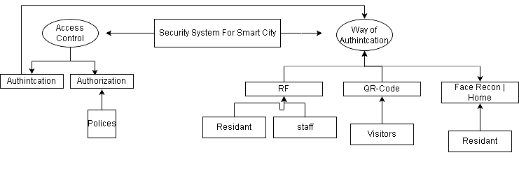

Figure 2.my model

The security system for the smart city depends on two main branches “access control” and “way of authentication” Access control : it has two main point in our security system “authentication” and “authorization” – that means the policy of the city that security system follows–Way of authentication : in our security system we have three ways RF -that will be used for the owners and the staff of the city- ,QR code-that will be used for the visitors(residents) and Face id -that will be used for the owner homes.

The security system consists of 2 layers of security for the first gate and 2 layers for the second gate to adapt the defense in depth strategy that means there must be from 2 to 3 layers. I am going to implement this in a 3 phases to complete the project. The first phase is collecting data and stating the role based rules and integrating the access control methods with each other. The second phase is going to be implementing the layers of the security system . The first layer of security to the first gate is going to be the login web page that will have a password that only the owner knows, the second layer of security is going to be the QR code generated from the web page that will be only available for 3 minutes. The second gate will have also 2 layers of security that is the radio frequency card (RF reader) and the face ID that will open the gate for the owners only. By applying this layer of security in my project I will be able to integrate the role based model access control method (RBAC) and the defense in depth strategy to enhance the smart cities security systems by a new and creative way. The third phase is going to test the system performance, reliability and accuracy. By the end of phase three the project must have a strong and accurate results to enhance the security performance in the smart cities.

## Functional/ Non-functional Requirements

**Functional Requirements:**

1. Access Control:

The system must implement secure and efficient access controls for the smart city.

1. Communication Infrastructure:

The system should establish reliable and secure communication channels between IoT devices.

1. Policy Administration:

The system must provide a user-friendly interface for administrators to define, update, and manage access control policies.

**Non-Functional Requirements:**

1. Scalability:

The system should be scalable to accommodate a growing number of IoT devices and users within the smart city.

1. Usability:

The user interfaces for security administrators should be user-friendly.

1. Reliability:

The system must operate reliably under normal conditions and do not conduct errors.

1. Performance:

Response times for critical security events should meet defined thresholds.

## Design / Simulation set up

**Sequence diagram:**

My sequence diagram provides a detailed representation of the step-by-step process for authenticating entities and granting or denying access in a smart city security system. It covers various authentication methods and permissions.

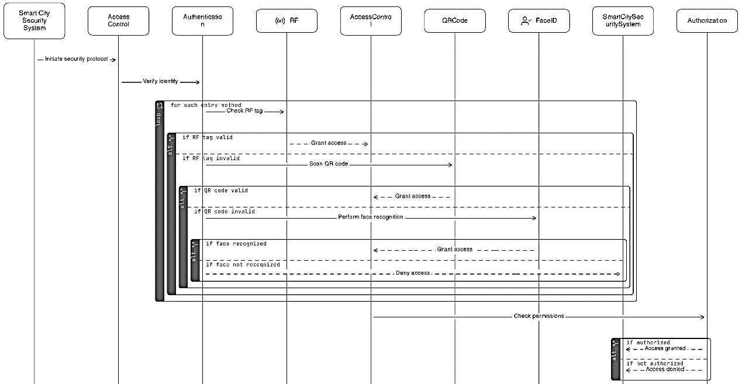

Figure 3.seq diagram

**components (Lifelines):**

1. **Smart City Security System**: Initiates the security protocol.
2. **Access Control**: Verifies identity.
3. **Authentication**: Manages different authentication methods.
4. **RF**: Handles RF tag checking.
5. **Access Control**: Checks access control based on authentication.
6. **QR Code**: Scans and verifies QR codes.
7. **Face ID**: Performs facial recognition.
8. **Smart City Security System**: Verifies permissions.
9. **Authorization**: Grants or denies access based on permissions.

**Process Flow**

1. **Initiate Security Protocol**: The process starts with the Smart City Security System initiating the security protocol.
2. **Verify Identity**: The Access Control verifies the identity of the entity attempting to gain access.
3. **For Each Entry Method**: The process iterates through multiple entry methods.

* **Check RF Tag**: The system checks the RF tag.
* If the RF tag is valid, access is granted.
* If the RF tag is invalid, the system moves to the next method.
* **Scan QR Code**: If the RF tag is invalid, the system scans the QR code.
* If the QR code is valid, access is granted.
* If the QR code is invalid, the system moves to the next method.
* **Perform Face Recognition**: If the QR code is invalid, the system performs facial recognition.
* If the face is recognized, access is granted.
* If the face is not recognized, access is denied.

1. **Check Permissions**: Regardless of the authentication method used, the system checks permissions.

* **If Authorized**: If the entity is authorized, access is granted.
* **If Not Authorized**: If the entity is not authorized, access is denied.

**Entity-Relationship Diagram (ERD):**

This ERD outlines how the system organizes and links access control data with various authentication methods and authorization policies.

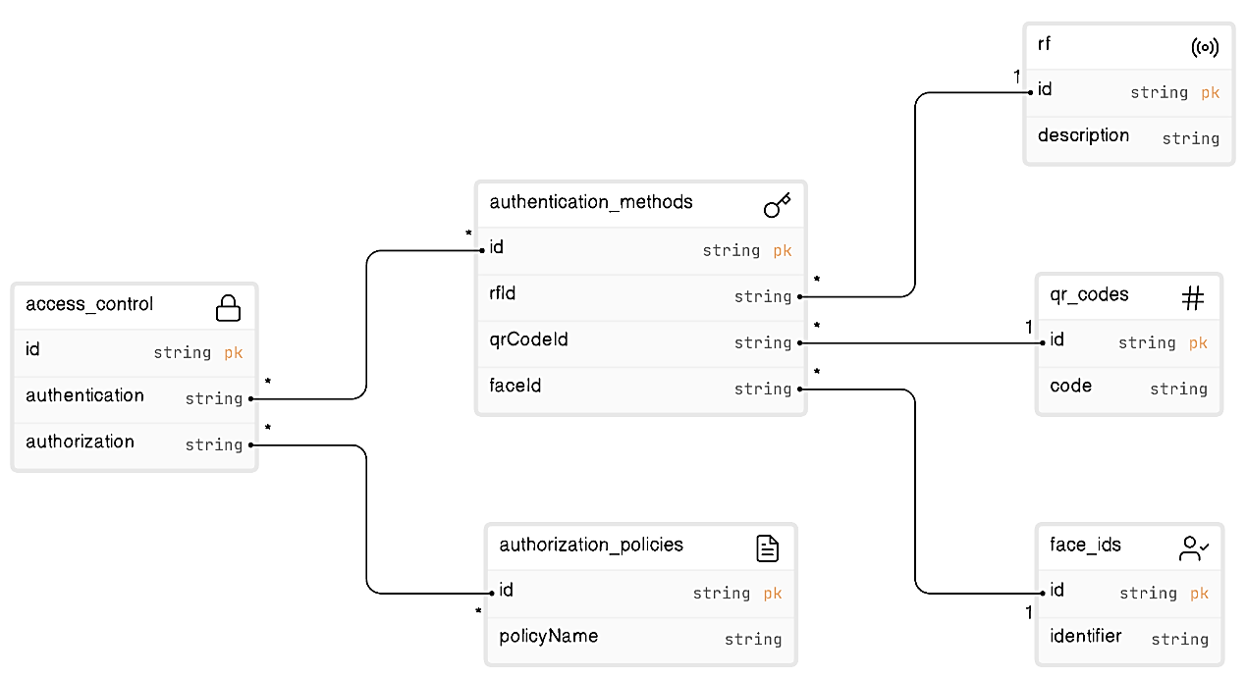

Figure 4.ERD

**Entities:**

* **access controls**
* **id**: string (Primary Key, pk)
* **authentication**: string
* **authorization**: string
* **authentication methods**
  + **id**: string (Primary Key, pk)
  + **rf Id**: string (Foreign Key)
  + **qr Code Id**: string (Foreign Key)
  + **face Id**: string (Foreign Key)
* **rf**
  + **id**: string (Primary Key, pk)
  + **description**: string
* **qr codes**
  + **id**: string (Primary Key, pk)
  + **code**: string
* **face ids**
  + **id**: string (Primary Key, pk)
  + **identifier**: string
* **authorization policies**
  + **id**: string (Primary Key, pk)
  + **policy Name**: string

**Relationships:**

* **access control** links to **authentication methods** through the **authentication** field.
* **access control** links to **authorization policies** through the **authorization** field.
* **authentication methods** have foreign key relationships to **rf**, **qr codes**, and **face ids**.
  + **rf Id** in **authentication methods** links to **id** in **rf**.
  + **Qr Code Id** in **authentication methods** links to **id** in **qr codes**.
  + **Face Id** in **authentication methods** links to **id** in **face ids**.

4. Implementation:

First of all, we have 4 components (Raspberry pi, camera, servo motor, RF reader). The second step is to setup the raspberry pi by raspberry imager that downloads the Linux on its memory. In the third step we are going to install VS code and the needed libraries from the raspberry pi terminal. Then we will start connecting the components to the raspberry pi pins as the following: The web cam will be connected through its USB to the raspberry USB port. The servo motor will be connected as the following figure

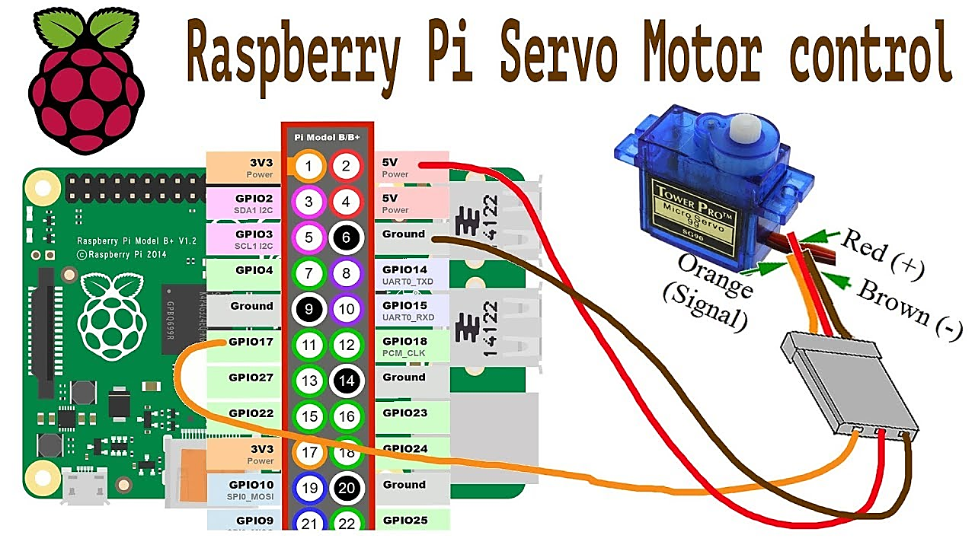

Figure 5.servo motor

The red jumper is the power port to the servo motor -> connected to the 5V power output pin of the raspberry pi

The brown jumper is the ground (-) of the servo motor -> connected to the ground of the raspberry pi

The orange jumper is the signal that will be used to act as we want in our code -> connected to GPIO17 (PIN number 11) as we used it in the code

Now we must connect the Radio frequency reader (RF reader) to the raspberry pi, it will be connected as the following figure:

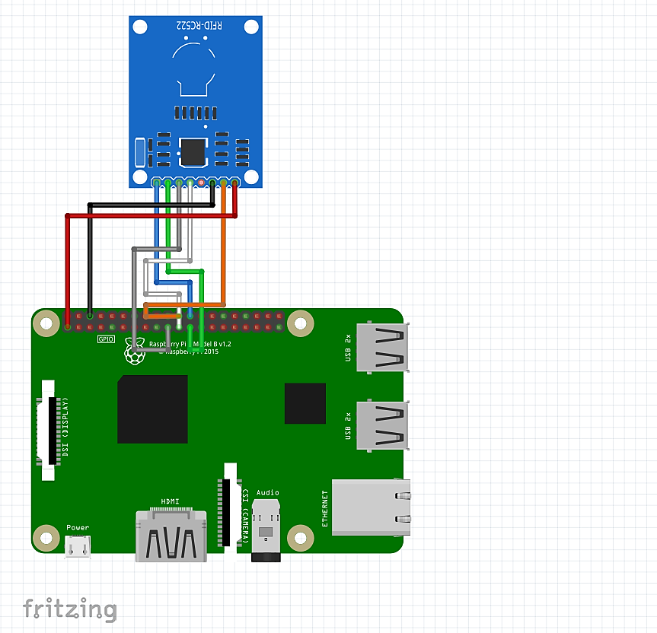

Figure 6.RF reader

SDA -> connected to pin 24

SCK -> connected to pin 23

MOSI -> connected to pin 19

MISO -> connected to pin 21

IRQ -> UNUSED

GND -> connected to pin 6

RST -> connected to pin 22

3.3V -> connected to pin 1

Here finally comes the VS code part, first script is written in flask I created very simple website for the residents of the city they will log in with their home number and the password that they will be given, if the logged in successfully they will be redirected to the QR generating page that will allow them to generate a QR code and send it to their visitors to enter the city from gate number 1 ( the visitors gate in my project, the QR gate).

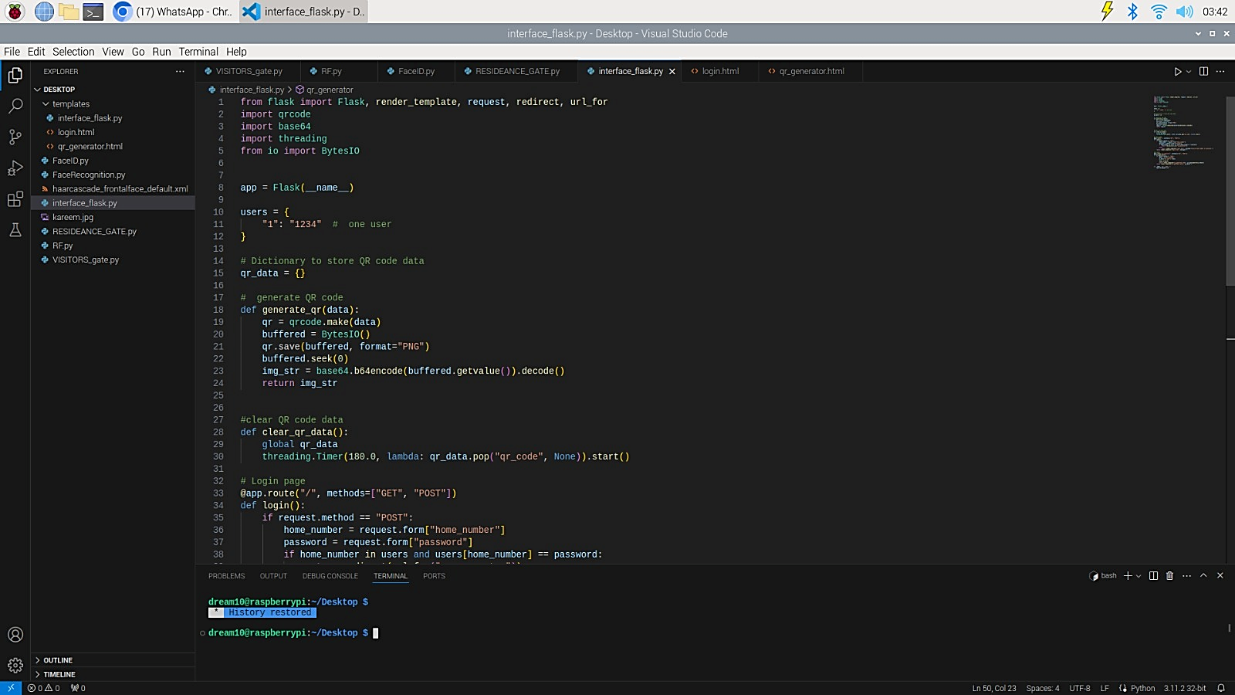

Figure 7

Adding the needed imports to my script



Figure 8

Line 8 initialize the flask app

Line 10 and 11 The users (Residents) in my project for now we have only one with home number 1 and password 1234

Line 15 empty dictionary to store QR code data

def generate_qr defines a function generate_qr that takes data as input and returns a base64-encoded QR code image:

def clear_qr_data starts a timer to clear the QR code data from qr_data after 180 seconds

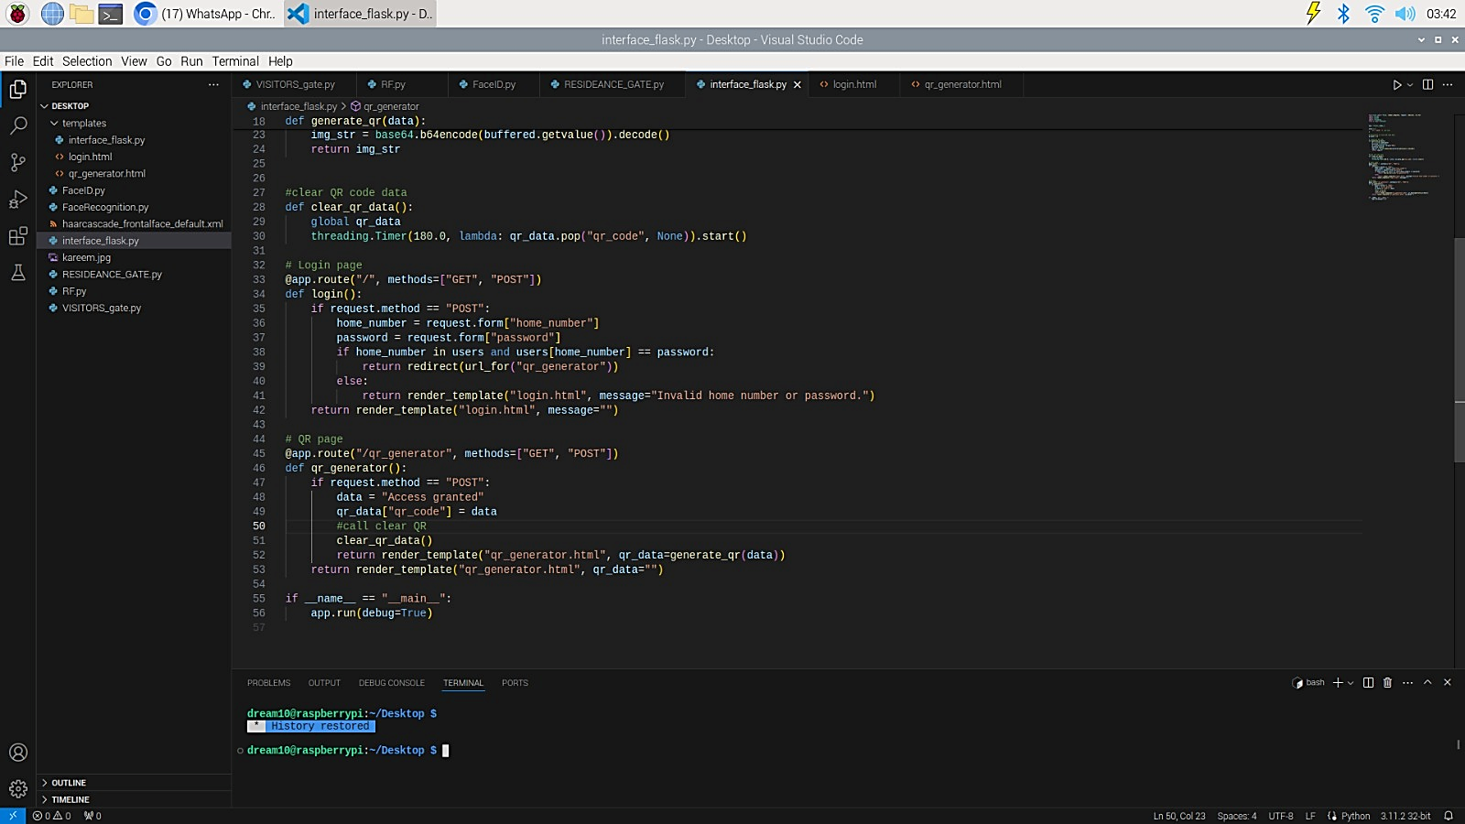

Figure 9

From line 32 to 42 is the route of the login page



Figure 10

From line 45 to 56 is the route of the QR generator page

Line 55 and 56 Runs the Flask app

Then design the HTML and RUN the script, the output:

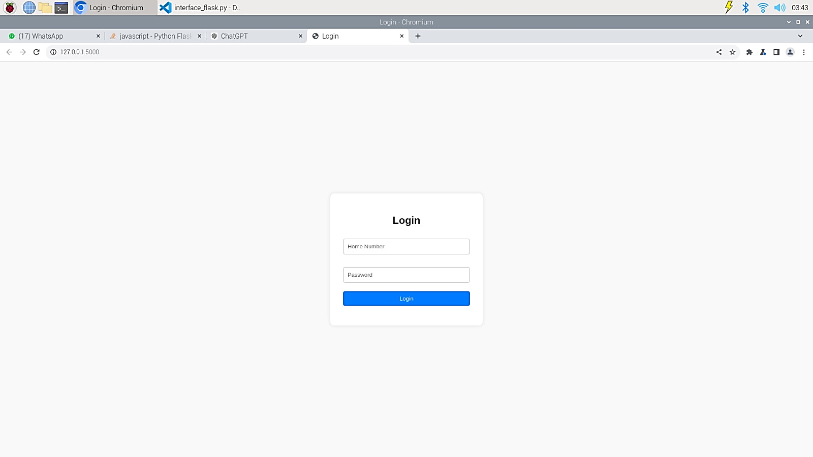

Figure 11

The login page to insert the user home number and password

If the home number or password is wrong, it displays error message and do not continue to the next page as shown in the figure below:

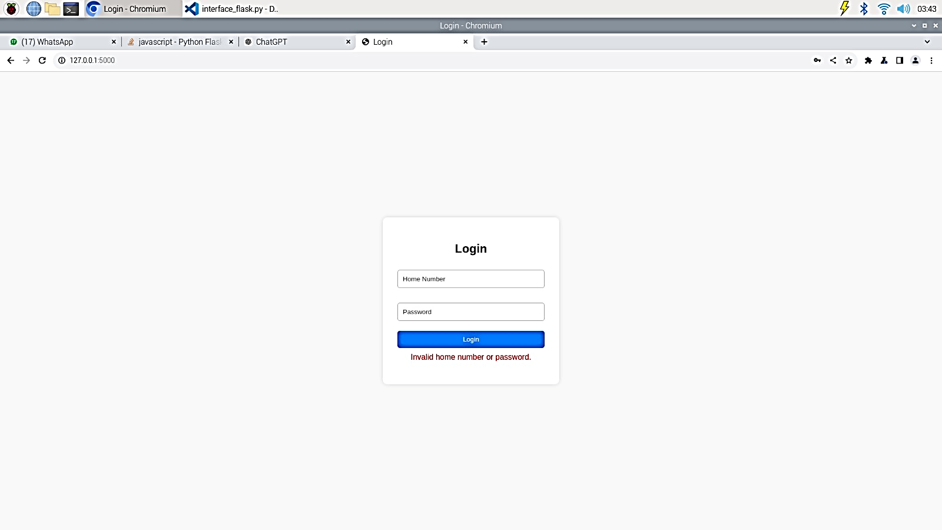

Figure 12

If the user provided correct home number name and password, then it will continue to the next page as the figure below:

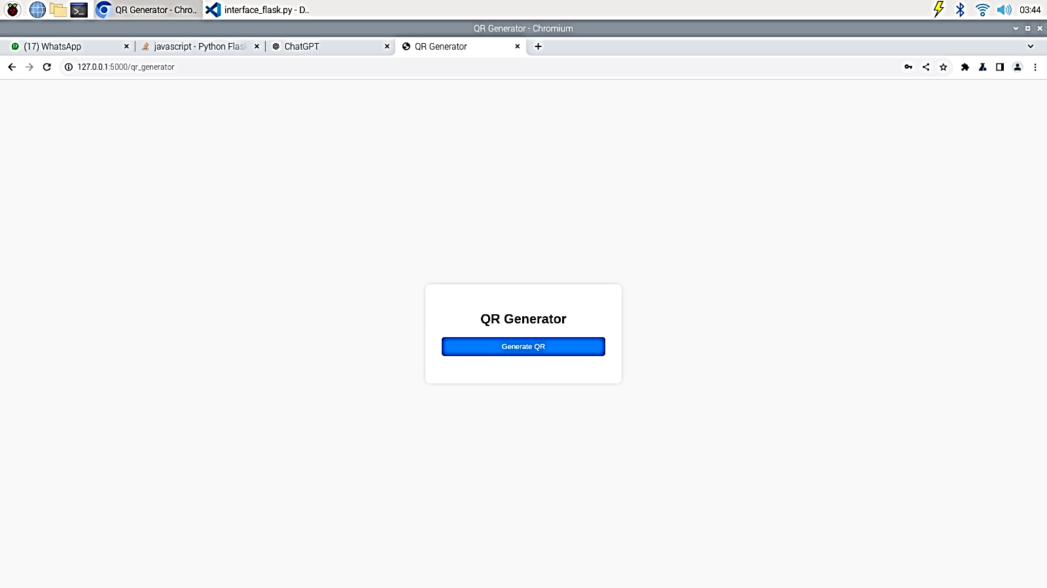

Figure 13

After login the QR generator appear press the Generate QR button to generate one

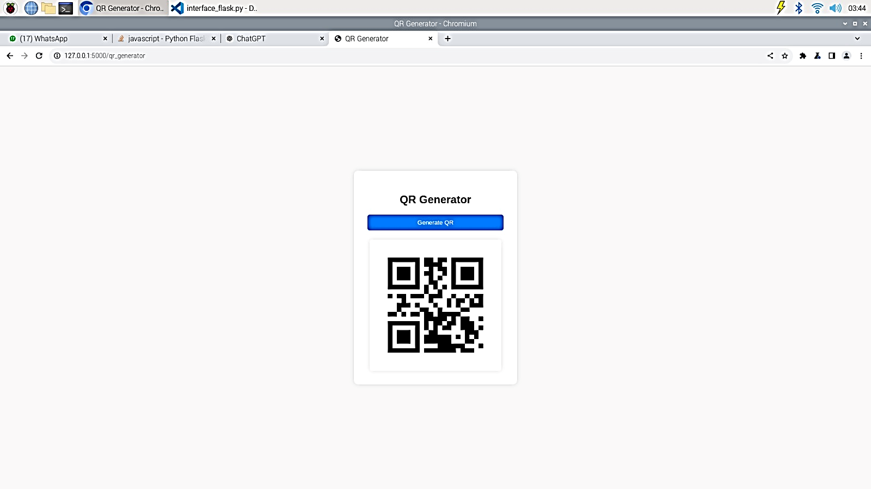

Figure 14

The QR Code is generated now it can be used to open the gate (the servo motor within 3 minutes).

Now we are back to the RF reader but now in the implementing phase

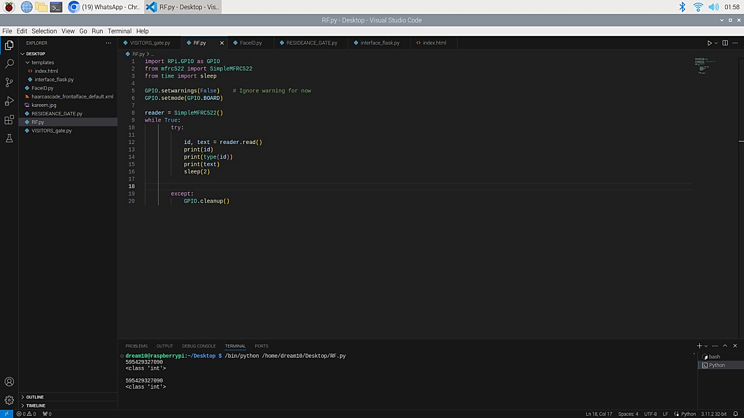

Figure 15

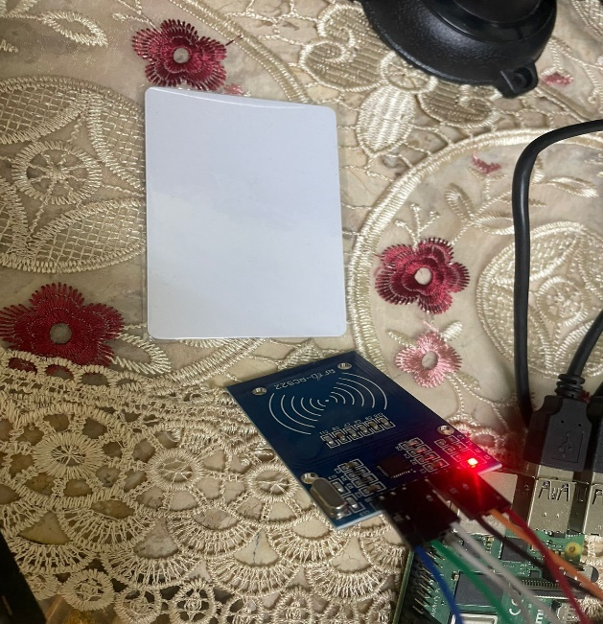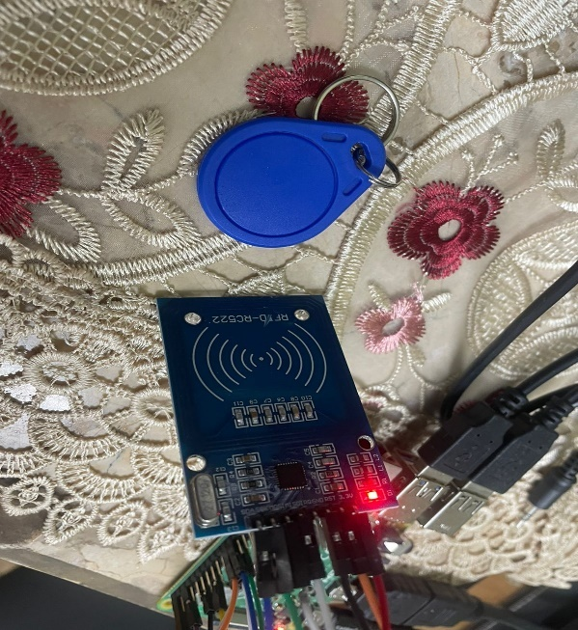This code is for knowing the ID number of the 2 cards by putting it in front of the RF reader as the following figures:

Figure 16

Figure 17

The output of the script will be the cards ids that will be as following figure:



Figure 18

After that we will implement the FaceID on 2 phases (face recognition then face identification) face recognition implementation is as the following figure:

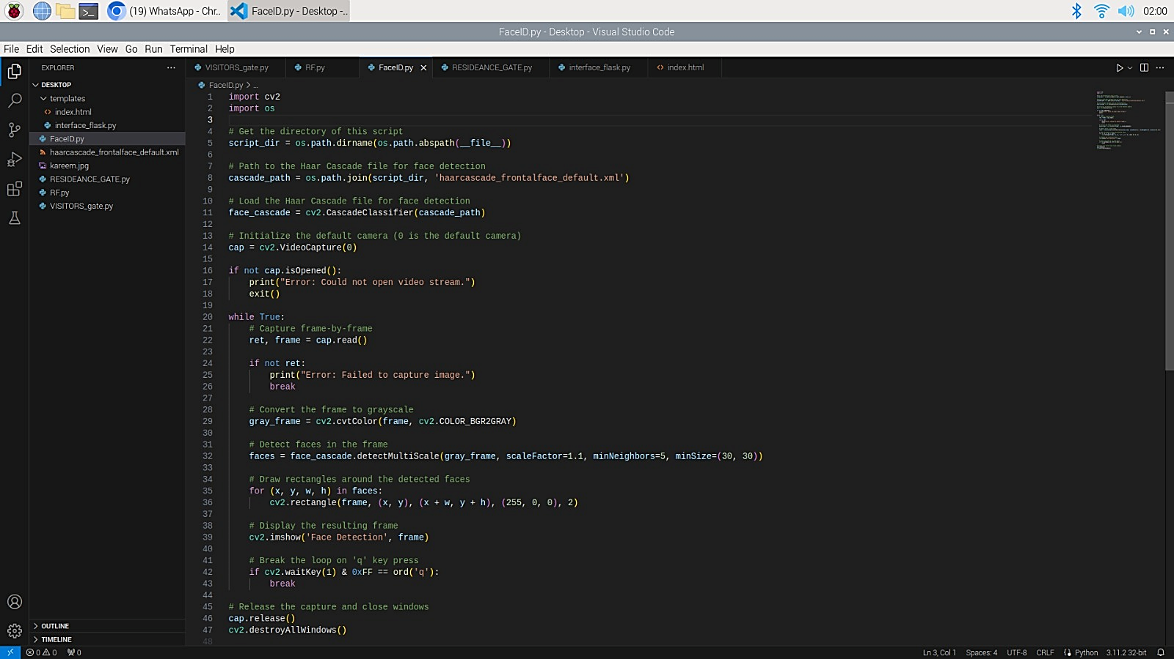In this script inserting the trained xml file to detect the faces automatically then draw a square around the detected face. The output:

Figure 19

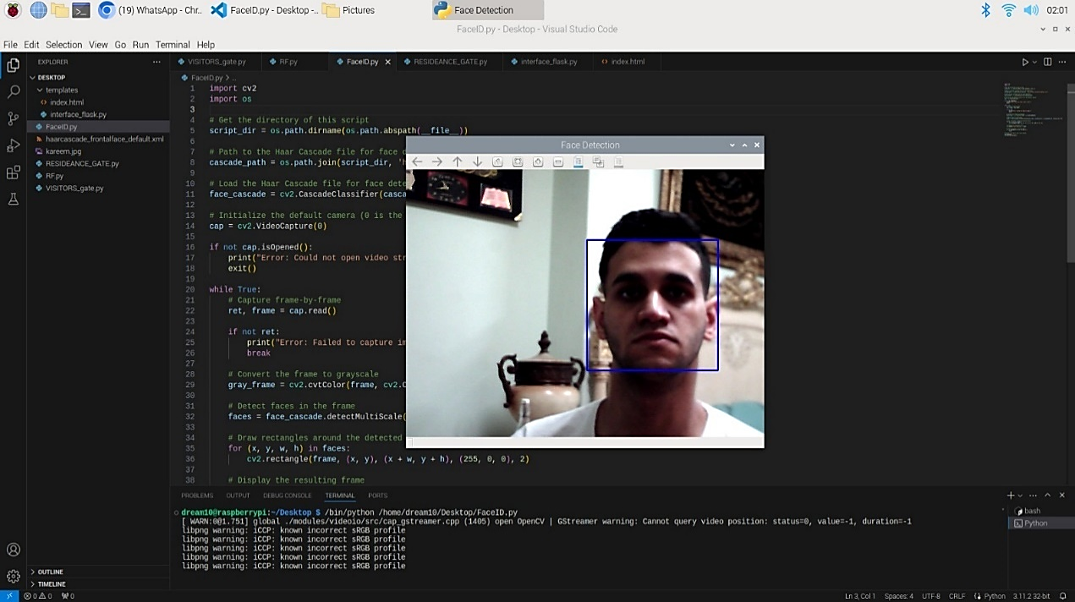

Figure 20

Now we are going to the first gate (the QR code gate – the visitors gate) implementation that will move the servo motor 180 degree after reading the valid QR code.

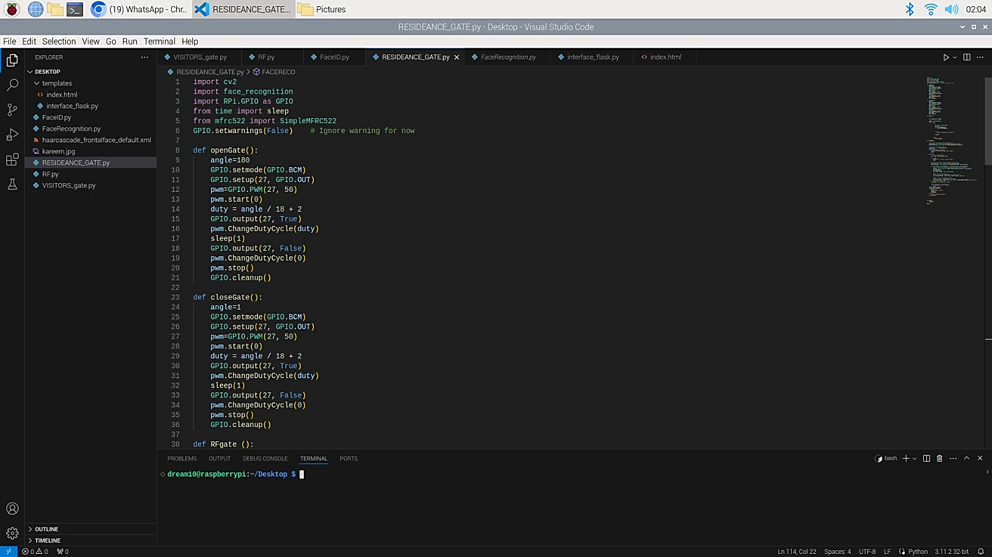

Figure 21

As always, the needed imports are added then the def openGate that opens the servo motor 180 degrees by Setting the angle to 180 degrees (fully open) then Sets the GPIO mode to BCM to read the pin number then configure GPIO pin 27 as an output sets up PWM on pin 27 with a frequency of 50 Hz that is standard and suitable for this type of servo motors then sets pin 27 to HIGH to accept frequency (to be on) changes the duty cycle to move the servo to the seted angle then it waits for 1 second before setting pin 27 to LOW (to be off) then Stops the PWM and PWM signal and clean the settings.

The def closeGate to close the gate again after opening it



Figure 22

The def begins by setting the angle to 1 degree (fully closed) then Sets the GPIO mode to BCM to read the pin number then configure GPIO pin 27 as an output sets up PWM on pin 27 with a frequency of 50 Hz that is standard and suitable for this type of servo motors,

Then sets pin 27 to HIGH 27 to HIGH to accept frequency (to be on) changes the duty cycle to move the servo to the setted angle then it waits for 1 second before setting pin 27 to LOW (to be off) then Stops the PWM and PWM signal and clean the settings.

Now implementation of the second and final phase of FaceID (Face Recognition) as follows:

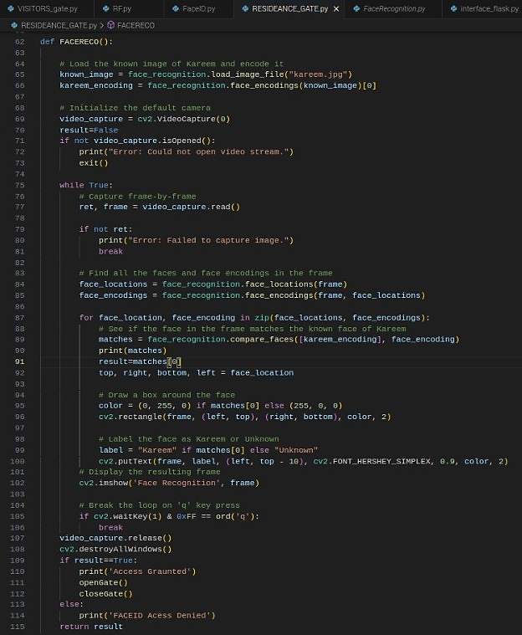

Figure 23

The def FACERECO begins with adding an photo of Kareem to encode into an array to compare it with the live stream of the cam and detect the face of kareem and prints kareem on the face and unknown on any other unknown name open the default camera (camera index 0) continuously captures frames from the video stream and detect all the faces in the frame then encodes the detected faces and compares the detected face encodings with Kareem's loaded encoding photo and draws a box around the face: green if it matches Kareem, red if not and labels the face as "Kareem" or "Unknown" and displays the frame with the rectangle and label and breaks the loop when 'q' key is pressed stop the video capture and closes the OpenCV windows so if the face captured matched kareem loaded photo it prints “Access Granted” if else it prints “Access denied”

The controller of the gate is the def RFgate as shown in the following figure :

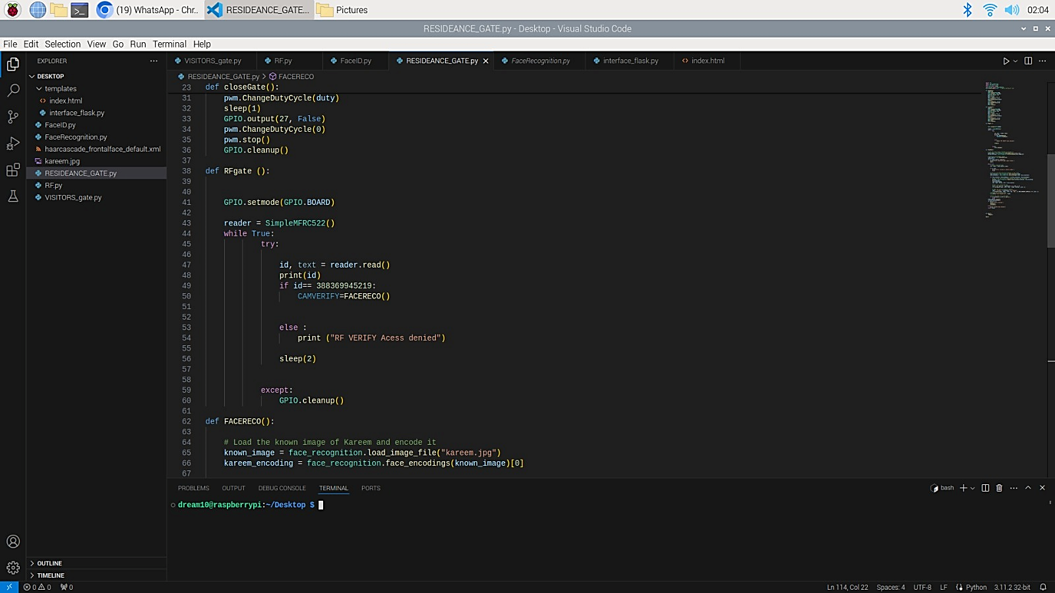

Figure 24

The code begins with setting the pin numbering mode of the GPIO pins to the pin numbering on the Raspberry Pi and reads the RFID reader using the SimpleMFRC522 to read the card ID number if the card ID number matches 388369945219 it calls the FACERECO function to check the face recognition if Card ID number did not match it prints "RF VERIFY Access denied" and waits for 2 seconds before continuing.

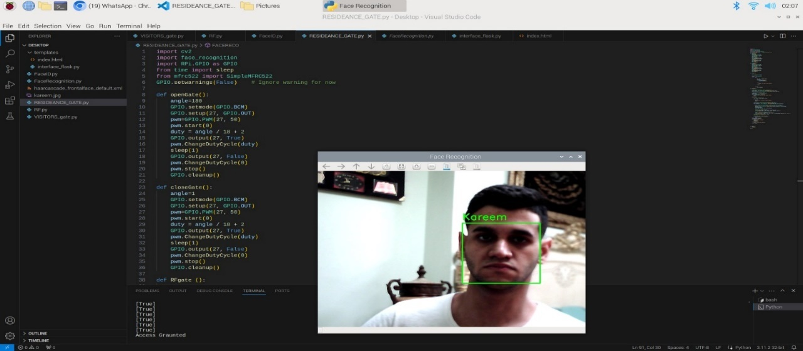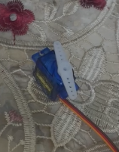In the following figures is the output when verifying the card id and kareem face as true, Printing “Access Granted and moving the servo motor 180 degrees to open.

Figure 25

Figure 26

In the following figure is the output when verifying the card ID is true but the face as false (unknown) it prints “Access denied” and the servo motor do not open (the gate remains closed)

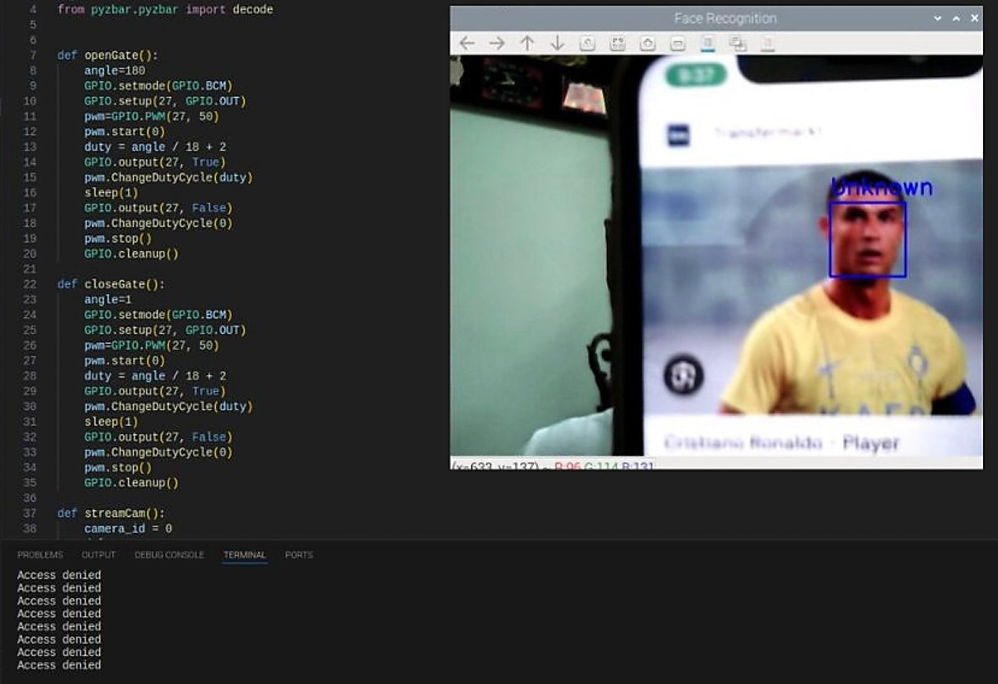

Figure 27

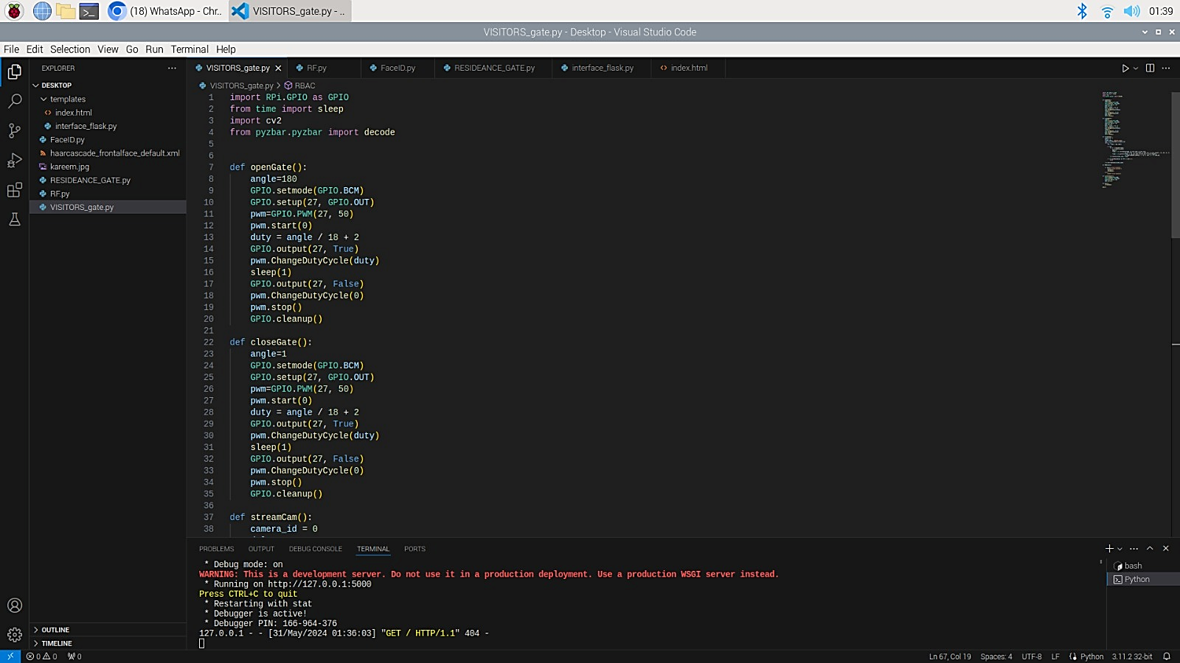The implementation of the visitors’ gate (QR code gate) will be as the following:

Figure 28

As always, the needed imports are added then the def openGate that opens the servo motor 180 degrees by Setting the angle to 180 degrees (fully open) then Sets the GPIO mode to BCM to read the pin number then configure GPIO pin 27 as an output sets up PWM on pin 27 with a frequency of 50 Hz that is standard and suitable for this type of servo motors then sets pin 27 to HIGH to accept frequency (to be on) changes the duty cycle to move the servo to the seted angle then it waits for 1 second before setting pin 27 to LOW (to be off) then Stops the PWM and PWM signal and clean the settings.

The def closeGate to close the gate again after opening it



Figure 29

The def begins by setting the angle to 1 degree (fully closed) then Sets the GPIO mode to BCM to read the pin number then configure GPIO pin 27 as an output sets up PWM on pin 27 with a frequency of 50 Hz that is standard and suitable for this type of servo motors, then sets pin 27 to HIGH 27 to HIGH to accept frequency (to be on) changes the duty cycle to move the servo to the setted angle then it waits for 1 second before setting pin 27 to LOW (to be off) then Stops the PWM and PWM signal and clean the settings.

Now the implementation of the live stream cam to read the QR codes as the following:

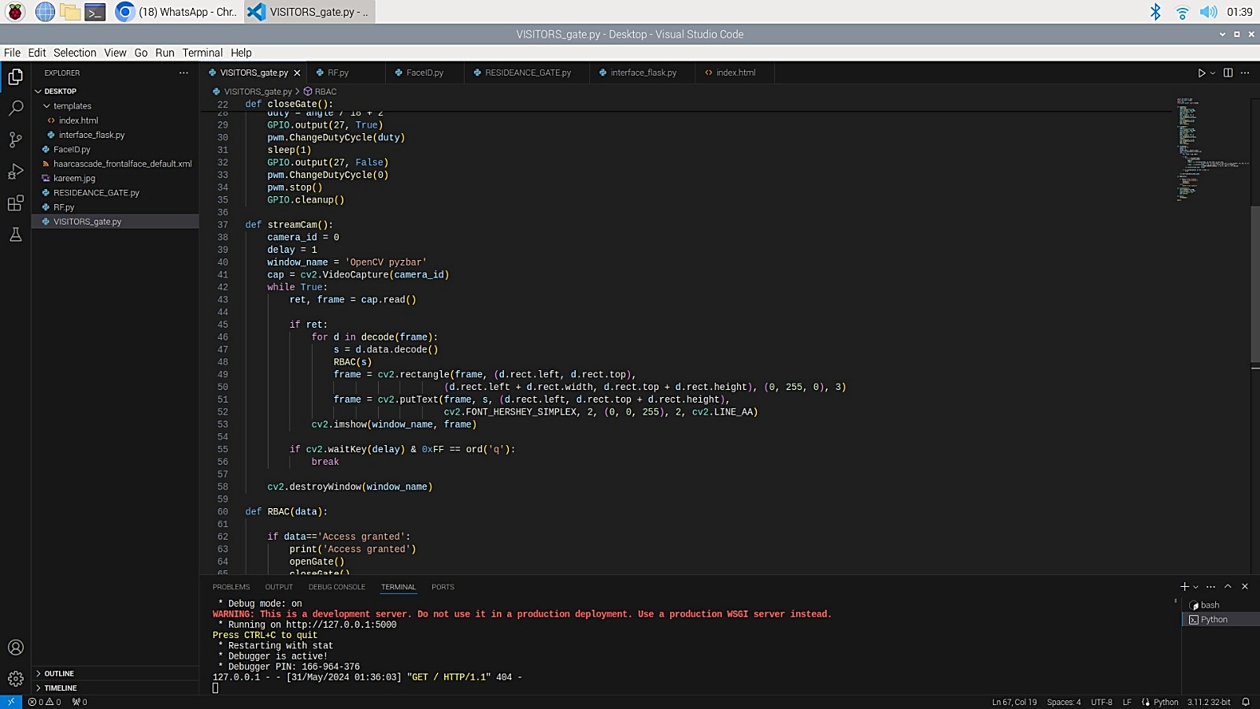

Figure 30

The def StreamCam begins with Setting the camera id to 0 to open the default webcam and setting a delay of 1 millisecond between frames to continuously reads frames from the camera when a frame is successfully read, it decodes the QR codes in the frame and returns a list of detected codes. Then draws a rectangle around the detected code to put the decoded text next to the rectangle then displays the processed frame and exits the loop when the 'q' key is pressed.

Now the implementation of the servo moto code to open when the QR code verified true and to remain closed when not will be as follows:

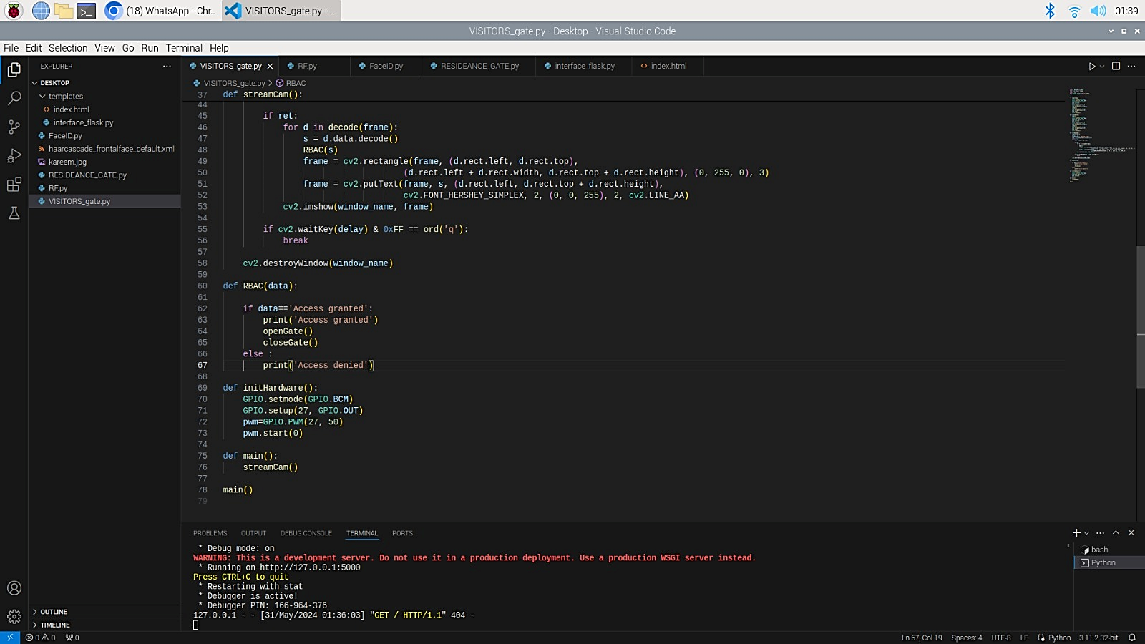

Figure 31

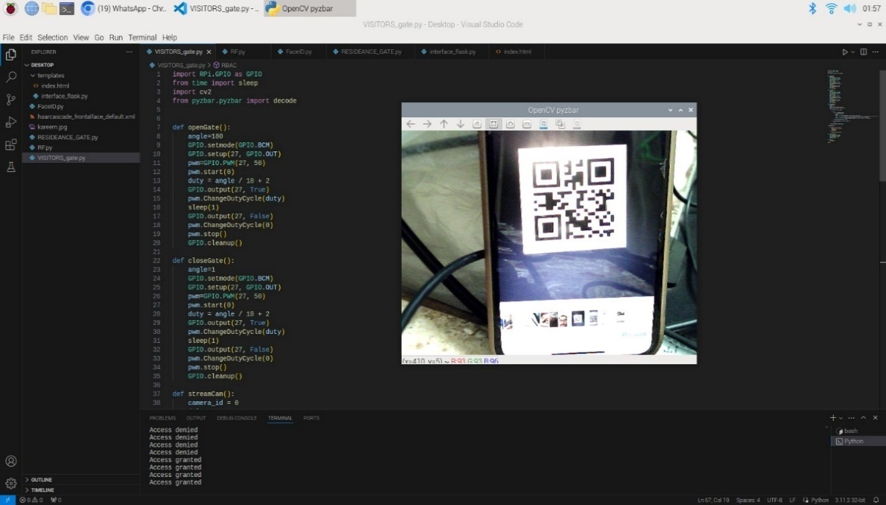The def initHardware begins by setting the pin numbers mode to BCM and pin 27 as output pin and the standard 50 HZ frequency then start it and the def main calls the StreamCam function that opens the camera and the servo motor opens if the QR code is truly generated from the website before 3 min or the servo motor remains closed if it is wrong QR code the outputs in the following figures:

Figure 32

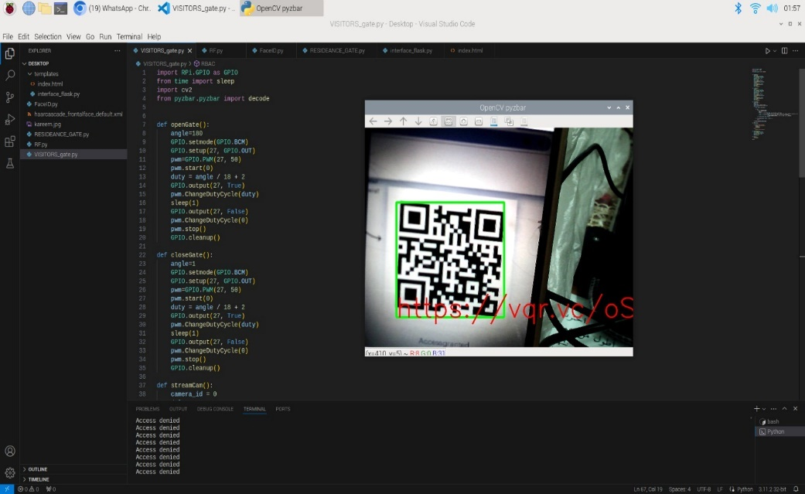

Figure 33

1. Testing and evaluation

## 5.1 Testing

**Login (Positive)**

|  |  |
| --- | --- |
| **Test Case ID** | TC_Login_1 |
| **Description** | The user should be able to login to the website with valid home number and password. |
| **Pre-Condition** | A user account already exists. |
| **Post- Condition** | Continue to the next page. |
| **Main path** | 1. Enter the home number: “1”.  2. Enter the password: “1234”.  3. Click on the Login button. |
| **Alternative path** | N/A |

Table 2

**Login (negative)**

|  |  |
| --- | --- |
| **Test Case ID** | TC_Login_2 |
| **Description** | The user should not be able to login to the website with wrong home number or password. |
| **Pre-Condition** | A user account do not exist. |
| **Post- Condition** | Display error msg. |
| **Main path** | 1. Enter the home number: “5”.  2. Enter the password: “7777”.  3. Click on the Login button. |
| **Alternative path** | N/A |

Table 3

**QRgate (positive)**

|  |  |
| --- | --- |
| **Test Case ID** | TC_QRgate_3 |
| **Description** | The servo motor should open 180 degrees when providing the correct QRcode. |
| **Pre-Condition** | N/A |
| **Post- Condition** | Servo motor open. |
| **Main path** | 1.put QR code in front of the camera. |
| **Alternative path** | N/A |

Table 4

**QRgate (negative)**

|  |  |
| --- | --- |
| **Test Case ID** | TC_QRgate_4 |
| **Description** | The servo motor should not open when providing wrong QRcode. |
| **Pre-Condition** | N/A |
| **Post- Condition** | 1.Servo motor not open.  2.Error msg display. |
| **Main path** | 1.put QR code in front of the camera |
| **Alternative path** | N/A |

Table 5

**RBACgate (positive)**

|  |  |
| --- | --- |
| **Test Case ID** | TC_QRgate_5 |
| **Description** | The gate should open when providing the correct RF card then the correct Face ID. |
| **Pre-Condition** | N/A |
| **Post- Condition** | Servo motor open. |
| **Main path** | 1.put the correct card in front of the RF reader.  2.put the correct face in front of the camera. |
| **Alternative path** | N/A |

Table 6

**RBACgate (negative)**

|  |  |
| --- | --- |
| **Test Case ID** | TC_QRgate_6 |
| **Description** | The gate should not open when providing the wrong RF card or wrong Face ID. |
| **Pre-Condition** | N/A |
| **Post- Condition** | 1.Servo motor does not open.  2.Error msg display. |
| **Main path** | 1.put the wrong card in front of the RF reader.  2.put the wrong face in front of the camera. |
| **Alternative path** | N/A |

Table 7

## 5.2 Evaluation

The evaluation of our system undergoes a thorough assessment to ensure it meets all the necessary requirements and objectives. We evaluated in the system's performance by conducting tests to ensure that it fulfils all the necessary requirements. This includes verifying secure access control, a trustworthy communication infrastructure, and simple to use policy control interfaces. In order to assess performance, we conducted an evaluation of the response times for important security events, making sure they meet the specified levels. Testing the system under normal operating conditions was crucial to ensure its reliability and error-free performance.

For our evaluation, we created accurate test scenarios to examine various aspects of the system. This involved checking the login functionality, QR code gate operations, and RBAC gate operations. We used indicators of performance such as response time, success rate, and error rate to evaluate the efficiency of the system.

The evaluation results indicated that the system performed well in all aspects. The system successfully met all the functional requirements, ensuring secure and reliable access controls. Performance indicators showed that response times were within acceptable levels, and the system operated reliably without any major errors.

In summary, the evaluation has confirmed that our system is strong, adaptable, and easy to use, perfectly adapting the requirements of a smart city security system.

1. Results and Discussions

The Results in my project have been high better compared to other papers and project results for the smart cities security that did not stated defence in depth strategy in the smart cities and used only one access control for accessing the city. I have stated defence in depth strategy along with integrating new creative access controls to add more secure and easy to use environment to the users that made accessing to the smart city by an unauthorized person is likely impossible because he will need owner by it self to pass the Face ID step which made the city much safer compared to other cities in the research papers.

The performance evaluation of our smart city security system gave impressive results across different measures. The system always showed fast response times, with Timings that were well within the acceptable levels. The success rates for critical security operations, such as login functionality, QR code gate access, and RBAC gate operations, were high, showing a reliable and consistent performance. The error rates were too low, showing the system's ability to handle a lot of scenarios with ease. Functional testing has shown that all core functionalities are working as expected, effectively handling secure access control and policy administration.

Based on our evaluation, it seems that the system has effectively met all of the criteria and objectives that were set. The remarkable success rates and small error rates clearly indicate that the system's implementation is dependable and effective. Our system exceeds related works discussed in the literature review, showing faster response times and improved user interface usability. This sets a new standard for smart city security systems. I was able to overcome the challenges that came up during implementation by conducting iterative testing. These efforts have led to the development of a system that is both effective and simple to use.

The findings have significant effects on smart city environments. The system's capacity to offer reliable, safe, and efficient access controls can greatly improve the overall security infrastructure of a smart city.

During our discussions, we recognised some areas that could be improved in the future. For example, we talked about the possibility of adding advanced security features like biometric identification and making the system more efficient for larger-scale use. These improvements can take the system's performance and flexibility to the next level, making sure it stays at the top of smart city security.

1. Conclusions and Future Work

## 7.1 Summary

The Smart City Security System project seeks to improve security and access management in smart cities by using Internet of Things (IoT) technologies and advanced access control mechanisms. Smart cities are all about creating urban environments that are integrated, habitable, and sustainable. They make use of IoT-enabled sensor technology to enhance social and urban connectivity.

The project aims to tackle the various challenges faced by smart city security systems, such as accuracy, scalability, real-time processing, privacy, and software-related security concerns. It is all around two primary branches: access controls and authentication methods.

The selected access control methods (RBAC) consist of authentication and authorization, with three authentication methods being RF (Radio Frequency), QR code, and Face ID. The project aims to enhance privacy and security in smart cities by utilizing appropriate algorithms and protocols to address connectivity and physical threats.

## 7.2 Future Work

After evaluating our smart city security system, we have discovered certain features that can be improved to enhance its capabilities and performance in the future. One thing that could be improved is the integration of enhanced security features. Implementing advanced biometric authentication methods, such as facial recognition or fingerprint scanning, can enhance security measures.

Scalability continues to be a key area of focus for future development. Our system has proven its capability to handle a growing number of devices. It's really exciting to think about how our security system could be integrated with other smart city systems. There's so much potential for future work in this region. Our solution can contribute to a more efficient and responsive smart city environment by connecting with traffic management, emergency response, and public health monitoring systems. This integration has the potential to transform data sharing and response coordination, making city management more efficient and effective. Finally, an important next step is implementing our system in an actual smart city setting. This deployment will give us some really useful data about how well the system performs and how effective it is in a real-life situation. It's a great opportunity to make any necessary improvements and test the system. With these future work initiatives, our smart city security system can keep evolving, establishing fresh objectives for urban security and operational efficiency.

References

[1] Ragothaman, K.; Wang, Y.; Rimal, B.; Lawrence, M. Access Control for IoT: A Survey of Existing Research, Dynamic Policies and Future Directions. Sensors 2023, 23, 1805. https://doi.org/10.3390/ s23041805

[2] Myagmar-Ochir, Y.; Kim, W. A Survey of Video Surveillance Systems in Smart City. Electronics 2023, 12, 3567. https://doi.org/ 10.3390/electronics12173567

[3] Bertin, E., Hussein, D., Sengul, C. et al. Access control in the Internet of Things: a survey of existing approaches and open research questions. Ann. Telecommun. 74, 375–388 (2019). https://doi.org/10.1007/s12243-019-00709-7

[4] K. Shafique, B. A. Khawaja, F. Sabir, S. Qazi and M. Mustaqim, "Internet of Things (IoT) for Next-Generation Smart Systems: A Review of Current Challenges, Future Trends and Prospects for Emerging 5G-IoT Scenarios," in IEEE Access, vol. 8, pp. 23022-23040, 2020, doi: 10.1109/ACCESS.2020.2970118.

[5] Ismagilova, E., Hughes, L., Rana, N.P. et al. Security, Privacy and Risks Within Smart Cities: Literature Review and Development of a Smart City Interaction Framework. Inf Syst Front 24, 393–414 (2022). <https://doi.org/10.1007/s10796-020-10044-1>

[6] Khanna, A., Kaur, S. Internet of Things (IoT), Applications and Challenges: A Comprehensive Review. Wireless Pers Commun 114, 1687–1762 (2020). <https://doi.org/10.1007/s11277-020-07446-4>

[7] Toh, Chai. (2020). Security for Smart Cities. IET Smart Cities. 2. 10.1049/iet-smc.2020.0001.

[8] Fabrègue, B. F. G., & Bogoni, A. (2023). Privacy and Security Concerns in the Smart City. Smart Cities, 6(1), 586–613. MDPI AG. Retrieved from <http://dx.doi.org/10.3390/smartcities6010027>

[9] M. Sookhak, H. Tang, Y. He and F. R. Yu, "Security and Privacy of Smart Cities: A Survey, Research Issues and Challenges," in IEEE Communications Surveys & Tutorials, vol. 21, no. 2, pp. 1718-1743, Secondquarter 2019, doi: 10.1109/COMST.2018.2867288.

[10] Baltaci, Nuray & Joshi, James. (2020). Access Control Approaches for Smart Cities. 10.1049/PBCE128E_ch1.

[11] : Namane, S.; Ben Dhaou, I. Blockchain-Based Access Control Techniques for IoT Applications. Electronics 2022, 11, 2225. https:// doi.org/10.3390/electronics11142225x